**Technical Instructions for SA2GE**

**PART I. Whole site**

**1. Objective**

Briefly introduce ***Le Regroupement*** and describe the responsibilities and vision of the organization *Le Regroupement*. It should be noted that *Le Regroupement* is a platform and a bridge as well, which brings together and connects various resources of the aviation industry and promotes cooperation between different organizations, companies, and institutions. Therefore, in the selection of images, slogans and texts, it is necessary to highlight the characteristics of *Le Regroupement* itself and avoid highlighting a small number of companies too much.

**2. Principles**

**2.1** **Responsive**. All pages should be responsive, that’s to say, each page can adapt to different platforms automatically.

*References:*

i. Documentation of html5 – responsive web design: <https://docs.microsoft.com/en-us/archive/msdn-magazine/2011/november/html5-responsive-web-design>

ii. Responsive breakpoints: <https://getbootstrap.com/docs/5.1/layout/breakpoints/>

**2.2** **Reusable**. Design components that can be reused, for example, the navbar, footer, buttons, search-bar, input field, and footer, etc.

*References:*

i. Component design principles: <https://reactjs.org/docs/design-principles.html>

ii. Collection of React components: <https://github.com/brillout/awesome-react-components>

**2.3** **Consistent**. Main colors, page layout, fonts, font size, etc, should be consistent.

**2.4 Accessible**. Implement the standards and requirements of WCAG 2.1.

*Reference:*

Accessibility (WCAG 2.1): <https://www.section508.gov/content/guide-accessible-web-design-development/>

**2.5** **Well-organized SEO**. Implement key requirements of SEO.

*Reference:*

SEO: <https://blog.hubspot.com/marketing/seo>

**3. Main frameworks and technologies**

3.1 React. For the development on client side.

3.2 Node.js. For the development on server side.

3.3 express.js. Popular framework of node.js.

3.4 MangoDB (optional). If use a database to host the data, we recommend MangoDB, otherwise could just use a JSON file to save the data.

**4. Main libraries and open sources**

4.1 Next.js (optional). Framework of React.

4.2 Bootstrap. Library for html, css and js. (<https://getbootstrap.com>)

4.3 Google fonts. Take care of most fonts on the pages. ([https://fonts.google.com](https://fonts.google.com/))

4.4 Fontawsome. Insert all kinds of icons (SVG) into html file. (<https://fontawesome.com>)

4.5 Unsplash. Open-source images. (<https://unsplash.com>)

**5. Development tools**

5.1 Visual Studio Code. Develop and test.

5.2 Git. Version management, we recommend Github.

5.3 Figma. UI design. (<https://figma.com>)

**6. Global settings**

**6.1 Basic CSS settings**

body {font-family:”Roboto”; font-size:16px; background-color:#fff; }

:root{--title-grey: #383838; --prefix-blue:# 3572B5; --bg-green-light:# 77A643; --bg-green-dark:# 5F883F; --font-weight-light:300; --font-weight-bold:700; --font-weight-semibold:600;}

h1 {font-size:3rem;font-weight:var(--font-weight-bold);line-height:1.0;color:var(--title-grey);}

h2 {font-size:2rem;font-weight:var(--font-weight-semi-bold);line-height:1.0;}

p {font-size:1rem; font-weight:var(--font-weight-light);}

a {text-decoration:none; cursor:pointer;}

li {list-style-type:none;}

**6.2 Layout**

This setting can make the footer sticked at the bottom of the page and keep the flexibility of header, content, and footer.

<!DOCTYPE html>

<html>

<head>

<title>Page Title</title>

<style>

html,body{height:100%;padding:0;margin:0;box-sizing:border-box;}

.container{height:100%;display:flex;flex-direction:column;}

.sizing{ width:100%;max-width:1140px;margin:0 auto;}

.header{height:125px;background-color:var(--title-grey);}

.main{height:100%;display:flex;flex-direction:column;}

.flexible-height{flex-grow:1;flex-shrink:0;}

.footer{height:205px;background-color: var(--title-grey);}

</style>

</head>

<body>

<div class="container">

<div class="main">

<div class="header">

<div class="sizing"></div>

</div>

<div class="content flexible-height">

<div class="sizing"></div>

</div>

<div class="footer">

<div class="sizing"></div>

</div>

</div>

</div>

</body>

</html>

*Reference link:*

i. flexbox: <https://css-tricks.com/snippets/css/a-guide-to-flexbox/>

ii. layout: <https://material.io/design/layout/understanding-layout.html#principles>

**7. Common components**

**7.1 Menu (navbar)**. It should be responsive. The item has sub-nav uses a dropdown list. For some sub-navs, they will be linked to the anchors of the destination page.

****Menu

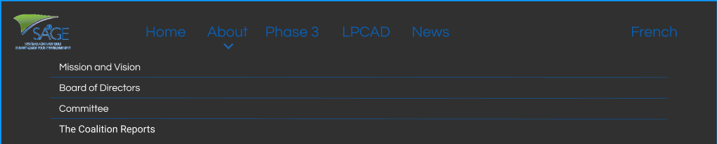Menu expanded

Menu on small screen

*Reference:* <https://getbootstrap.com/docs/5.1/components/navbar/>

**7.2 Footer**. The elements will be displayed vertically on small screen.

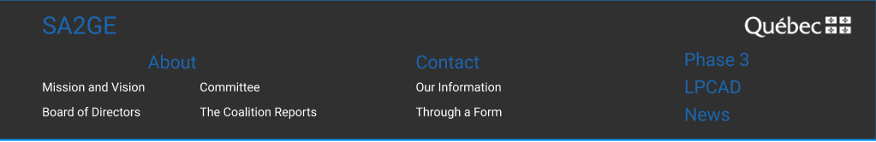

**7.3** **Favicon**. Redesign the favicon according to the standards and methods in the reference article.

Reference link: <https://evilmartians.com/chronicles/how-to-favicon-in-2021-six-files-that-fit-most-needs#:~:text=Set%20the%20width%20and%20height,bit%20alpha%2C%20no%20palette%20settings.&text=Scale%20the%20image%20down%20to,and%20check%20the%20icon%20visibility>.

**PART II: Home page**

**1. Hero image**. Two choices: a well-designed static image or dynamic slides.

Dynamic slides (images should cover as many companies as possible which are partners of Le Regroupement, each image could have its own title).

Static image (the image needs to be designed to reflect the nature and vision of Le Regroupement). There’s no link on the image or images.

*References:*

i. Hero image idea: <https://colibriwp.com/blog/hero-websites/>

ii. Slides technique: <https://getbootstrap.com/docs/5.1/components/carousel>

**2. Industrial partners section**

The list is separated into 5 columns evenly and each cell has the same height. Each image has a link to the company’s website.



**3. Section reports**

The gallery is with a hover effect. The report of 2021 is open by default. When the cursor hovers over a report, the image will have double width and three others single width.

On the mobile device, display and unfold the images vertically with the same logic and certainly it’s better to choose horizontal images.

*Reference*:

Hover effects: <https://codepen.io/knyttneve/pen/YgZbLO>

**PART III: Mission and Vision**

For the graphic, there’re two choices. The first one is just using an image. The second one is creating a react component to make it dynamic.

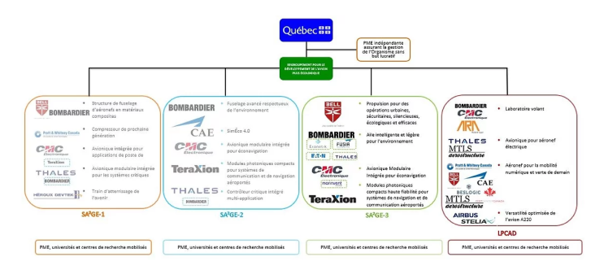

If choosing the second option, here’s the reference to the library that can help create a mindmap.

*Reference*:

React-mindmap: <https://www.npmjs.com/package/react-mindmap>

**PART IV: Board of Directors**

**PART V: Phase 3**

**PART VI: LPCAD**

**PART VII: News**